**Meaning and Definitions:**

Leadership is the ability to build up confidence and zeal among people to create an urge them to be led. To be a successful leader, a manager must possess the qualities of foresight, drive, initiative, self-confidence and personal integrity. Different situations may demand different types of leadership. Leadership has been defined in various ways. Stogdill has rightly remarked that there are almost as many definitions of leadership as there are people who have tried to define it.

**The definitions given by some famous authors and management experts are given below:**

“Leadership is the ability of a manager to induce subordinates to work with confidence and zeal.”—Koontz and O’Donnell.

“Leadership is the exercise of authority and making of decisions.” —Dubin, R.

“Leadership is the ability to secure desirable actions from a group of followers voluntarily, without the use of coercion.”—Allford and Beaty.

“Leadership is the activity of influencing people to strive willingly for group objectives.”—George R. Terry.

“Leadership is the initiation of acts which result in insistent pattern of group interaction directed towards the solution of mutual problem.” —Hemphill, J.K.

“Leadership is a process of influence on a group in a particular situation at a given point of time, and in a specific set of circumstances that stimulates people to strive willingly to attain organisational objectives and satisfaction with the type of leadership provided.”—Jame J. Cribbin.

“Leadership is not making friends and influencing people i.e., salesmanship. It is the lifting of man’s visions to higher sights, the raising of man’s personality beyond its normal limitations.”— Peter Drucker.

In the various definitions of leadership the emphasis is on the capacity of an individual to influence and direct group effort towards the achievement of organisational goals. Thus, we can say that leadership is the practice of influence that stimulates subordinates or followers to do their best towards the achievement of desired goals.

**Nature and Characteristics:**

**An analysis of the definitions cited above reveals the following important – characteristics of leadership:**

1- Leadership is a personal quality.

2. It exists only with followers. If there are no followers, there is no leadership.

3. It is the willingness of people to follow that makes person a leader.

4. Leadership is a process of influence. A leader must be able to influence the behaviour, attitude and beliefs of his subordinates.

5. It exists only for the realization of common goals.

6. It involves readiness to accept complete responsibility in all situations.

7. Leadership is the function of stimulating the followers to strive willingly to attain organisational objectives.

8. Leadership styles do change under different circumstances.

9. Leadership is neither bossism nor synonymous with management.

**Leadership Styles or Types of Leaders:**

The term ‘leadership style, refers to the consistent behaviour pattern of a leader as perceived by people around him. Every leader develops a pattern in the way he handles his subordinates or followers in various situations. The leadership style is the result of the philosophy, personality and experience of the leader. It also depends upon the types of followers and the conditions prevailing in an organisation.

**I. Leadership Style Based on Attitude and Behaviour:**

**According to their attitude and behaviour patterns leaders are classified as under:**

1. Autocratic or authoritarian style leader.

2. Laissez-faire or Free-rein style leader.

3. Democratic or participative style leader.

4. Paternalistic style leader.

**1. Autocratic or Authoritarian Style Leader:**

An autocratic also known as authoritarian style of leadership implies yielding absolute power. Under this style, the leader expects complete obedience from his subordinates and all decision-making power is centralized in the leader. No suggestions or initiative from subordinates is entertained. The leader forces the subordinates to obey him without questioning. An autocratic leader is, in fact, no leader. He is merely the formal head of the organisation and is generally disliked by the subordinates. The style of leadership may be practiced to direct those subordinates who feel comfortable to depend completely on the leader.

**2. Laissez-faire or Free-rein Style Leader:**

Under this type of leadership, maximum freedom is allowed to subordinates. They are given free had in deciding their own policies and methods and to make independent decisions. The leader provides help only when required by his subordinates otherwise he does not interfere in their work. The style of leadership creates self-confidence in the workers and provides them an opportunity to develop their talents. But it may not work under all situations with all the workers and under all situations. Such leadership can be employed with success where workers are competent, sincere and self-disciplined.

**3. Democratic or Participative Style Leader:**

The democratic or participative style of leadership implies compromise between the two extremes of autocratic and laissez-fair style of leadership. Under this style, the supervisor acts according to the mutual consent and the decisions reached after consulting the subordinates. Subordinates are encouraged to make suggestions and take initiative.

It provides necessary motivation to the workers by ensuring their participation and acceptance of work methods. Mutual trust and confidence is also created resulting in job satisfaction and improved morale of workers. It reduces the number of complaints, employee’s grievances, industrial unrest and strikes. But this style of leadership may sometimes cause delay in decisions and lead to indiscipline in workers.

**4. Paternalistic Style Leader:**

This style of leadership is based upon sentiments and emotions of people. A paternalistic leader is like a father to his subordinates. He looks after the subordinates like a father looks after his family. He helps guides and protects all of his subordinates but under him no one grows. The subordinates become dependent upon the leader.

**II. Formal and Informal Leader:**

**Leadership style based on official Recognition/Relationship:**

**From the view point of official recognition from top management, leaders may be classified as under:**

1. Formal Leader

2. Informal Leader

**1. Formal Leader:**

A formal leader is one who is formally appointed or elected to direct and control the activities of the subordinates. He is a person created by the formal structure, enjoys organisational authority and is accountable to those who have elected him in a formal way. The formal leader has a two-fold responsibility. On the one hand, he has to fulfill the demands of the organisation, while on the other he is also supposed to help, guide and direct his subordinates in satisfying their needs and aspirations.

**2. Informal Leader:**

Informal leaders are not formally recognized. They derive authority from the people who are under their influence. In any organisation we can always find some persons who command respect and who are approached to help guide and protect the interest of the people. They are known as informal leaders.

The informal leaders have only one task to perform, i.e., to help their followers in achieving their individual and group goals. Informal leaders are created to satisfy those needs which are not satisfied by the formal leaders. An organisation can make effective use of informal leaders to strengthen the formal leadership.

**III. The Managerial Grid:**

**Leadership style based on concern for production v/s concern for people:**

Robert R. Brake and Jone S. Mounton developed the Managerial Grid which has been used as a means of managerial training and of identifying various combinations of leadership: (i) Concern for people; and (ii) concern for production.

**There are five representative styles of leadership on the managerial grid:**

**1. Impoverished Management:**

The first style (1.1) is the impoverished management under which the manager is least concerned with either people or production. “Exertion of minimum effort to get required work done is appropriate to sustain organisation members.”

**2. Country Club Management:**

The country club management as shown in grid at 1.9 is one in which the management (leaders) have great concern for their people but lack production orientation. “Thoughtful action to needs of people for satisfying relationships leads to a comfortable friendly organisation atmosphere and work tempo.”

**3. Task Management:**

“Efficiency in operations result from arranging conditions for work in such a way, that human elements interfere to a minimum degree.” As shown in the grid at 9.1, the leaders with high concern for production fall under this style. Their concern for people, however, is minimum.

**4. Team Management:**

“Work accomplishment is from committed people, interdependence through a common stake in organisation purpose leads to relationships of trust and respect.” As shown in the grid at 9.9, the leaders having high concern for production as well as people fall under this style.

**5. Middle of the Road:**

“Adequate organisation performance is possible through balancing the necessity to get out work while maintaining morale of people at a satisfactory level.” This has been shown in the grid at 5.5. The leaders of this style have medium concern for both people and production and try to maintain a balance in the two.

The managerial grid implies that the most desirable leader behaviour is team management (9.9) in which the leader has high concern for production as well as people. The managerial grid is useful for identifying various combinations of leadership styles. But it is unable to point out the factors which lead the manager to such a style.

[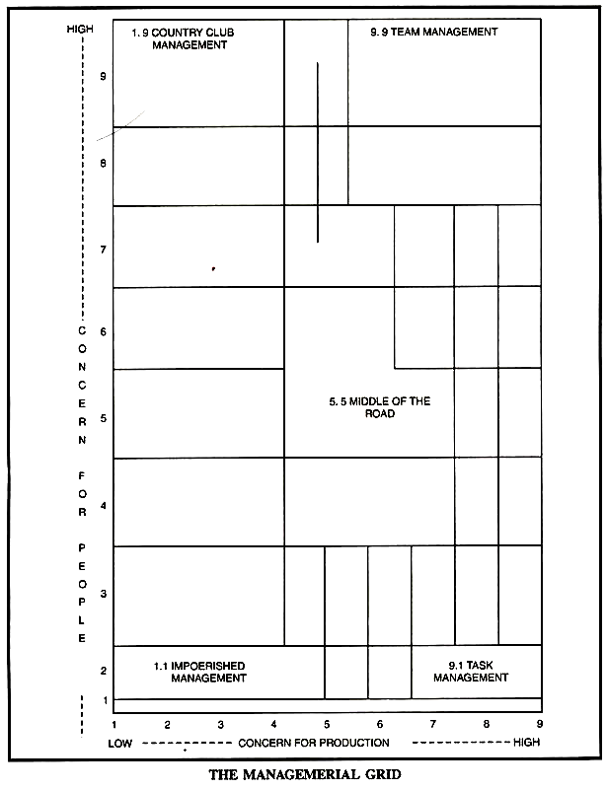](http://cdn.yourarticlelibrary.com/wp-content/uploads/2015/08/image54.png)

**IV. Leadership Style Based on Decision Making:**

Rensis Likert was the Director of Michigan Institute of Social Research, U.S.A. He conducted extensive research for fourteen years with the help of 40 researchers in the field of leadership. His famous writings include: New ‘Patterns of Management’ published in 1961 and ‘Human Organisation’ published in 1967.

Likert treats the organisation as a complex system based on the principle of supporting relationships, in which decision-making, leadership, motivation, communication and control move together. He was of the view that these variables are measurable and could be related to production and profit over time. He recognized the organisation as a social system made up of interrelated work groups having group loyalties. He was also of the view that traditional job oriented supervision was the cause of low productivity and low morale. He suggested participating management in the field of decision-making.

**He classified leadership styles into four categories:**

**(i) Exploitative Autocratic:**

In this style, there is no participation of workers because these leaders have no confidence and trust in subordinates.

**(ii) Benevolent Autocratic:**

There is no proper confidence in subordinates and the relationship is that of a master and servant.

**(iii) Participative:**

The subordinates are allowed to participate in decisions involving their lives. Leader does not have full confidence in them.

**(iv) Democratic:**

In this style the confidence and trust in subordinates is full and they meaningfully participate in decision-making. Likert has used a continuum of four managerial systems, i.e., from system 1 to system 4. Table given below shows some of the main characteristics of these systems.

[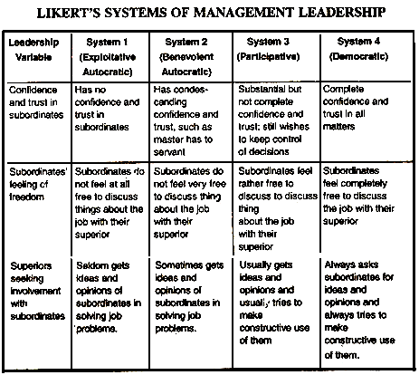](http://cdn.yourarticlelibrary.com/wp-content/uploads/2015/08/image55.png)

System 1 of management leadership is described as ‘exploitative autocratic’; its managers have no confidence and trust in subordinates, seldom get ideas and opinions of subordinates in solving job problems, motivate people through fear and punishment and engage in downward communication.

System 2 management is referred to as ‘benevolent autocratic’; its managers have condescending confidence and trust in subordinates such as master has to servant, sometimes get ideas and opinions of subordinates and opinions of subordinates in solving job problems, motivate people with rewards and some fear and punishment and permit some upward communication.

System 3 management is described as ‘participative’ ; managers in this system have substantial but not complete confidence and trust in subordinates, still wish to keep control of decisions, usually get ideas and opinions of subordinates, motivate people with rewards and occasional punishment and permit both upward and downward communication.

System 4 management is referred to as ‘democratic’. It is characterised by the use of the principle of supportive relationships and group methods of supervision. Managers in this system have complete confidence and trust in subordinates in all matters, always ask subordinates for ideas and opinions and always try to make constructive use of them, encourage decision-making throughout the organisation, and reward people in economic terms. Subordinates feel free to discuss the job and their problems with their superiors.

Low producing units were generally found under system 1 and 2 management whereas systems 3 and 4 represented consistently high production units. In general, Likert observed that system 4 style of leadership is the best and the managers who applied it to their operations had greater success as leaders.

However, he has explicitly remarked that “differences in the kind of work, in the traditions of industry and in the skills and values of the employees of a particular company will require quite different procedures and ways to apply appropriately the basic principles of system 4 management”. However, the most appropriate leadership technique is one which is based on interaction between styles, group and situation as these variables largely affect the performance of the organisation.

**Leadership Functions:**

**Following are the important functions of a leader:**

**1. Setting Goals:**

A leader is expected to perform creative function of laying out goals and policies to persuade the subordinates to work with zeal and confidence.

**2. Organizing:**

The second function of a leader is to create and shape the organisation on scientific lines by assigning roles appropriate to individual abilities with the view to make its various components to operate sensitively towards the achievement of enterprise goals.

**3. Initiating Action:**

The next function of a leader is to take the initiative in all matters of interest to the group. He should not depend upon others for decision and judgement. He should float new ideas and his decisions should reflect original thinking.

**4. Co-Ordination:**

A leader has to reconcile the interests of the individual members of the group with that of the organisation. He has to ensure voluntary co-operation from the group in realizing the common objectives.

**5. Direction and Motivation:**

It is the primary function of a leader to guide and direct his group and motivate people to do their best in the achievement of desired goals. He should build up confidence and zeal in the work group.

**6. Link between Management and Workers:**

A leader works as a necessary link between the management and the workers. He interprets the policies and programmes of the management to this subordinate and represent the subordinates’ interests before the management. He can prove effective only when he can act as the true guardian of the interests of the subordinates.